Scoil Bhríde
Clara Co Offaly
Roll No: 13118U

Special Educational Needs Policy

This policy was initially formulated in May 2013. Updating the SEN Policy was identified as a priority following the review of the SEN Allocation Model by the Department of Education and the introduction of the new model “The Continuum of Support”. Ms Rochford the Special Educational Needs Co-ordinator (SENCO) was tasked with revising, updating and amending this policy in accordance with Circular 0013/2017. This was drawn up in consultation with the Principal, class teachers, support teachers and parents and ratified by the BOM.

Our Position Statement
At Scoil Bhríde it is our intention to foster a harmonious environment which focuses on nurturing the unique potential of each individual:
- To create a positive and inclusive atmosphere that respects all children.
- To ensure that children with SEN have access to a broad, balanced curriculum.
- To work in partnership with parents and carers.
- To collaborate with other agencies and professionals to develop pupils academic, social, emotional and independent living skills.
- We are committed to providing access to additional resources for children with SEN as resources permit
Definition
Children have special Educational needs if they have a learning difficulty which calls for special educational provision to be made for them.

Children have a learning difficulty if they;
- Have a significantly greater difficulty in learning than the majority of children the same age/or
- Have a disability which prevents or hinders them from making use of educational Facilities of a kind generally provided for children of the same age in school.

Areas of need may relate to;
- Communication and interaction
- Cognition and learning
- Behavioural, emotional and social development
- Sensory and or physical needs
- Medical conditions (some pupils in school have medical conditions but no SEN). All medical administration will be managed in line with our Medical Administration Policy and staff will be trained to administer specific medication if deemed necessary.

Aims /Objectives in relation to SEN
We aim to;
- Give every child the opportunity to experience success in learning and achieve their potential.
- Create an inclusive environment in line with the Education Welfare Act 2000, Education for persons with Disabilities Act 2004 and DES Circulars 24/03, circular 02/05 and circular 0013 /17
- Ensure that all children gain access to a broad and balanced curriculum and have an equal opportunity to receive an education that is appropriate to their needs.
- Endeavour to create a positive ethos and an inclusive atmosphere that respects all children.
- Overcome potential barriers to learning and assessment and enable active participation in learning and in school life for all children with SEN.
- Eliminate discrimination and promote equality in line with Equal Status Act 2000.We aim to provide reasonable accommodation of people with disabilities. We aim to promote equality for those who are disadvantaged or need special facilities or arrangements.
- Be mindful of our duties as set out in Education Act 1998, which states that Scoil Bhríde “(will) ensure that the educational needs of students, including those with disability or special needs, are identified and provided for “
- Take into account children with SENs diverse learning needs, strengths, backgrounds, interests and experiences when setting suitable learning challenges.
- Develop pupils, academic, social, emotional and independent living skills.
- Take into account the ascertainable wishes of children.
- Develop a strong collaborative partnership with parents and carers.
- Collaborate effectively as a staff in Scoil Bhríde to improve the learning outcomes of students with SEN.
- Collaborate with outside agencies e.g. HSE, NCSE, DES to share information as required.
- Identify, assess and support pupils with SEN as early as possible before/upon entry to school using the continuum of support framework.
- Provide a graduated approach in order to match educational provision to children’s identified needs.
- Monitor and review our effectiveness in achieving the above objectives.

Guiding Principles
In line with Special Education Circular 0013/2017. We aim to;
- Provide and allocate a wide range of Resources to support pupils with SEN in order to facilitate inclusion.
- Choose and allocate appropriate supports methodologies and approaches based on identified priority learning needs of children with SEN, informed by regular reviews of progress and in consultation with parents and children.
- Make sure that all staff are aware of their roles and responsibilities including the class teacher who has the primary responsibility for the progress and care of all pupils in the classroom, including pupils with SEN
- Use our Special education teaching supports solely for the benefit of children with identified SEN including children with EAL.
- Ensure that the children with the greatest levels of need have access to the greatest level of support and wherever possible are supported by teachers with relevant expertise who can provide continuity of support.
- Develop a core team of SET teachers with relevant expertise and experience and provide them with access to continual professional development to support the diverse needs of pupils with SEN

Transitions
- Home school liaison teacher and SET teacher will meet with preschool teachers to discuss and identify children with SEN prior to school entry.
- Home school teacher will assist in referring children to AON (Assessment of need) or EIT (Early Intervention Team)
- Playschool teacher will meet in Term 2 of the school year with Junior Infant class teacher and SET teacher /SENCO, where possible to share information.
- Principal and SENCO will meet parent of pupil with identified SEN to discuss concerns upon or prior to entry where possible.
- Home school teacher from secondary school will meet with sixth class teacher to pass information in last term.
- SENCO will meet parent to discuss and assist transition of pupil with SEN to secondary school.
- SENCO will meet with SENO, NEPS and secondary school SET where deemed necessary for pupils with complex needs to facilitate smooth transition to second level.

Identifying Pupils with Additional Needs
Special educational needs range from mild to severe and transient to long term This framework ensures that children get different levels of support depending on their identified educational needs. Pupils with the greatest level of need have access to the greatest levels of support. Interventions are incremental moving from class based interventions to more intensive individualised support.

The Continuum of Support Framework
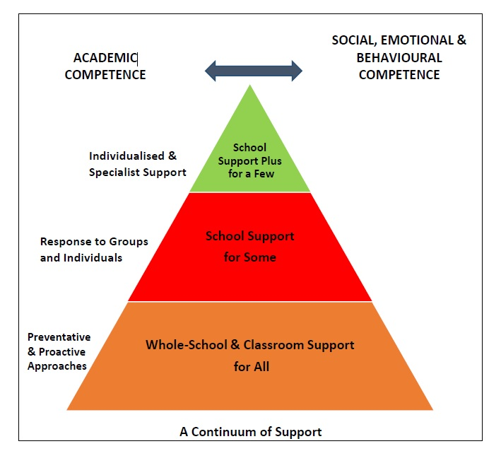

Stage 1: Classroom Support
- The classroom support plan is developed over time to meet the needs of those pupils who do not respond to the differentiated programme. It is a response for children who have social, emotional, behavioural or learning needs which are additional to or different from those required by other pupils. It is initiated in response to concern expressed by parent /teacher /professional.
- Classroom support process is coordinated by the class teacher and carried out in the regular classroom. It is informed by observation, testing, teacher screening, profiles, interview schedule, learning environment checklists, classroom support checklist.
- Classroom support plan is developed in consultation with parents and pupil (where appropriate)
- It is implemented by parent and class teacher. A classroom support plan outlines the pupil’s additional needs, individual approach and actions.
- Classroom support plan is reviewed after an agreed period to assess progress /effectiveness. The plan may be then continued at classroom level, altered, or discontinued (to continue with differentiated teaching approaches).
- Children are identified as early as possible and referred for speech and language therapy, occupational therapy by the class teacher in consultation with the SENCO.
- If concerns remain after a number of reviews and adaptations to the plan the pupil moves to school support process.

Stage 2: School Support
If considered necessary/or following a number of reviews and adaptations to the classroom plan.
- School support is the next phase which is usually coordinated by SET Teacher and SENCO working alongside the class teacher. The Class teacher consults the SET Teacher / SENCO to clarify the concern. The classroom support process is reviewed.
- The coordinating teacher is involved in gathering further information, assessment and completing School support checklist. Assessment tools and checklists are used to identify strengths and priority areas of need.
- A school support plan/IPLP is now devised in consultation with SET teacher, parents, pupil and class teacher. Strategies, targets and Suitable teaching approaches (including team teaching, small group or individual tuition) are identified to best meet the priority learning needs. A school support plan is implemented by class and SET teacher for an agreed period of time and is then reviewed
- A school support plan is reviewed and a decision is made to discontinue and return to classroom support, continue or amend plan at school support.
- If significant concerns remain after a number of reviews and adaptations to the learning programme the school support plus process is initiated.
- The school will involve relevant external agencies if necessary and the pupil may be referred with parental consent for a detailed psychological Assessment and or to a multi-disciplinary team.

Stage 3: School Support Plus

Some pupils with more complex and enduring identified needs arrive in school and move straight to school support plus. Concern is expressed by parent /teacher /other professional
- Or If following school support reviews and after a period of time it is recognised that a pupil has persistent complex needs, the pupil will move to school support plus.
- Coordinating teacher arranges a review of records, Coordinates assessment and gathers information and assessment involving class teacher SET teacher, external professionals, pupil and parent
- A school support plus plan is now devised. This is done in consultation with parents, pupil, outside professionals, and teacher. This is a more detailed, individualised plan, with identified strengths and needs, long term goals, and priority learning needs.
A pupil at school support plus may need more intensive long term support including focused small group or individual tuition. Approaches are identified, monitored and reviewed to address the priority learning needs.
- Reports and advice will be provided by the multi-disciplinary team to assist with differentiating the curriculum and resources and classroom organisation
- Review progress and decide to redefine problem and continue at school support plus level and review SSP/ IEP or discontinue SSP/ IEP and implement school support plan.

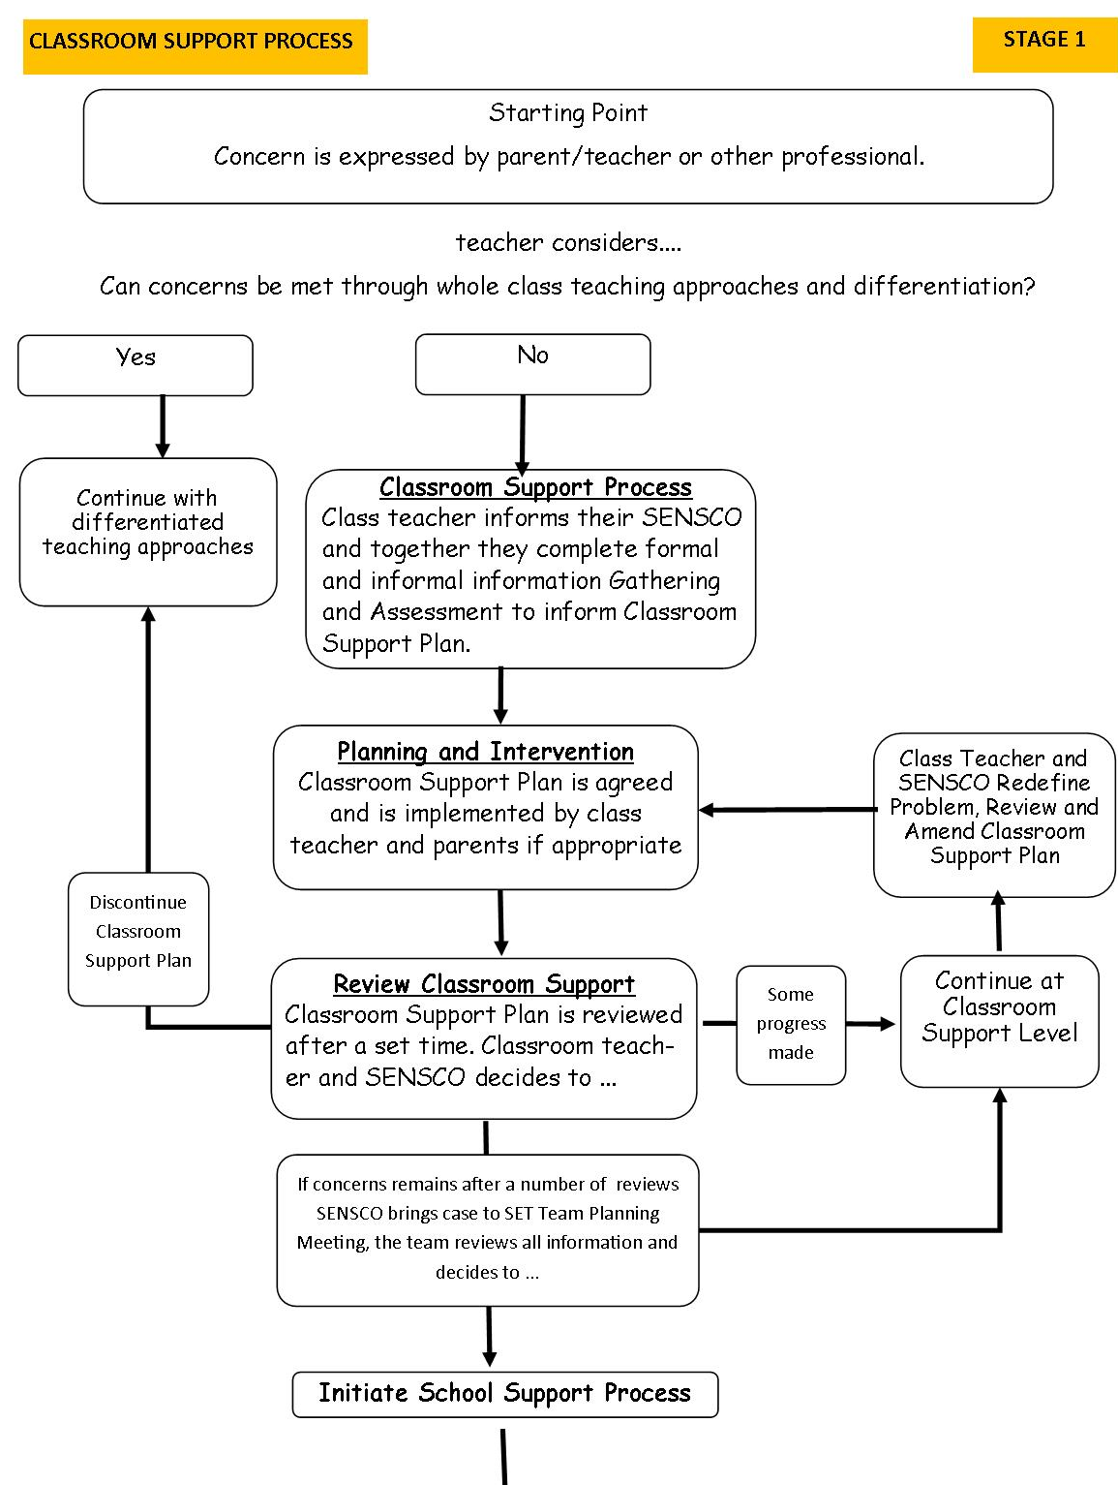

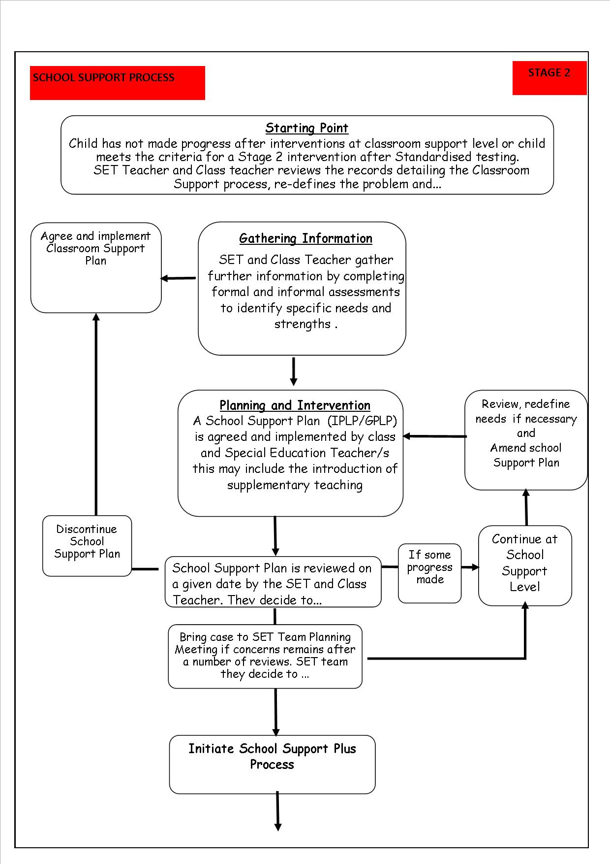

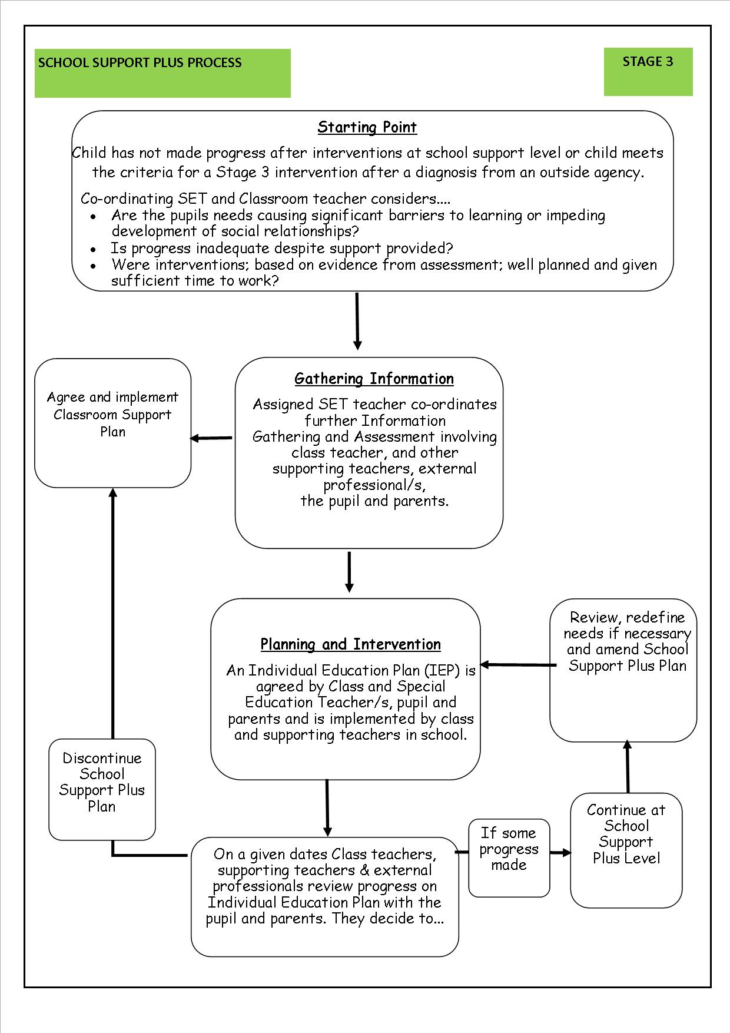

Assessment Guidelines

Identification of Pupils with Special Educational Needs
Assessment is carried out informally on a daily basis by the class teacher and includes self-assessment, questioning, teacher observation, portfolios of work, teacher designed tasks and tests.

Standardised Testing
Standardised testing is carried out annually at whole school level

Infants
- Junior infants; observation checklists, selected pupils with identified needs are formally assessed using the BIAP
- All senior infants are assessed using observation checklists, MIST test and /or Drumcondra profile, malt or math recovery test.
- Children are identified for classroom support or school support for literacy support using these tests and parent, teacher consultation.

First to Sixth.
- The MICRA T, SIGMAT, observation checklists are administered in first to sixth
class in the third term
- The NRIT test is given in last term of 3rd class.

Early Intervention/prevention initiatives
Based on identified needs in literacy and numeracy in our school the following evidenced-informed early-intervention/ prevention programmes are prioritised.

Reading Recovery
- A number of teachers have trained and attend continual CPD in Reading Recovery.
- Children will be recommended for further assessment-based n identified needs .EG where they don’t perform well in formal testing in MIST or fail to make significant progress in reading and in consultation with class teacher and parent
- Children identified as having needs in literacy in senior infants or first class between the age of 5.5yrs and 6 yr.5s are given the observation survey tests by the reading recovery trained teacher.
- The children with the greatest need are prioritised.
- A minimum of 2-4 children each year will receive intensive one to one support in reading recovery for a minimum of 20 weeks.
- Reading Recovery Assessment identifies strengths and needs, progress is tracked, recorded and reviewed at end of the intervention.

Maths Recovery
- Children are identified as at risk of failure in maths using assessment. The Malt and Maths Recovery tests are given to all pupils at the end of senior infants.
- The maths recovery intervention focuses on first class
- Identified children receive one to one or small group support.
- This is a short term intervention usually of about 12 weeks
- Specialist maths recovery teachers deliver the programme.
- Maths Recovery assessment is carried out at beginning and end of programme. The child progress is tracked and recorded.

Whole School or Classroom Support for all
These initiatives can lead to improved outcomes for pupils.
- Reading Recovery led literacy lift off is a 6-8-week intervention designed to improve reading levels. It allows common needs to be met by dynamic grouping. Progress in reading is assessed, tracked and recorded using pm benchmark kit. A number of SET teachers and class teacher are involved in co teaching. First class, junior and senior infants are the targeted classes.
- Maths station teaching is short term intervention that groups children according to common needs. Progress in maths is assessed tracked and recorded. A number of SET Teachers and class teacher are involved in co-teaching. First class are targeted for early intervention.
- Guided reading intervention facilitates graded group reading in junior classes. A SET Teacher and class teacher are involved.
- Promotion of Numeracy includes Ready set go maths programme, and maths for fun is run in junior and senior infants for a number of weeks with parental involvement encouraged.
- Oral language and language in maths is given priority.
- Promotion of literacy is given priority. Phonological awareness and phonics are given strong emphasis in junior classes.
- AISTEAR is given priority in infant classes.
- There is strong collaboration and frequent consultation between infant teachers, SET teachers and SENCO. Additional support is given in the areas of language, Social skills, literacy and early maths where possible and early identification of needs encouraged.

Priority of SEN Access Provision in line with Continuum of Support

The children with the greatest levels of need should have access to the greatest level of support.
- Pupils will be prioritised for additional teaching support based on continuum of support. In order of priority of educational profile of need and within the limits of resources available.
- Pupils who have low incidence disabilities. These children have more complex, enduring needs and may have been assessed by an external professional (psychologist and/or multi-disciplinary team) will be prioritised.
- Children who have high incidence disabilities or who have identified needs and may have been assessed by an outside professional .eg psychologist (dyslexia, MLD, language difficulties etc.)
- Children who have not made adequate progress after interventions at school support level.
Individualised Early Intervention programmes; e.g. reading recovery, Maths recovery for identified at risk senior infants /first class. Pupils with EAL in infants.
- Pupils who have not made adequate progress after classroom support plans involving interventions and reviews at classroom support level;
- These may involve children with learning, language, social, emotional, behavioural or sensory needs and may also include;
- Children who perform below the10th percentile in English
- Children who perform below the12th – 15th percentile in English
- Children who fall below the 10th percentile in maths
- Children who fall below the 12-15 percentile in maths
- Pupils 1st to 6th EAL

Teaching Methods and Approaches
Following assessment, we Identify the level and the type of intervention required to meet targets for each pupil on the Continuum of Support. Common needs are met where considered appropriate by grouping to ensure effective and efficient teaching and learning. We employ a range of approaches such as differentiation, heterogeneous grouping, team-teaching and small group teaching. Provision will be provided in the form of individual, small group withdrawal to a quiet area with access to a teacher where deemed appropriate and in consideration of what is most suited to the Pupil with SENs individual needs, placement on continuum, funding and human resources available. Intervention programmes are chosen to meet identified needs. Pupils with the greatest level of need will receive the greatest level of support from teachers with relevant experience. SET and SSP/IEP Team meetings are held at least once a term to review effectiveness, progress or difficulties arising and decisions are taken to adapt, continue or discontinue interventions.

Success Criteria
- Positive feedback from teachers, parents, pupils.
- Policy review at staff meeting staff discussion to explore effectiveness.
- Regularly evaluate arrangements for SEN
- Regularly review SEN policy.
- Staff in-service.

Roles and Responsibilities;

Class Teacher
The class teacher has primary responsibility for progress and care of all pupils in the class including pupils with SEN.
The class teacher will;
- Administer and correct standardised tests
- Create a positive learning environment within the classroom.
- Meet parents to discuss concerns and to review classroom support plan /iep regularly
- Gather information through interview, observation, testing, checklists etc
- Have responsibility for developing classroom support plans.
- Discuss concerns with SENCO to assist in selection of pupils for support.
- Collaborate with team to develop school support plan /gplp/iplp
- Devise school support plus plans/ IEP with SET teacher and IEP te.
- ensure the child is offered all possible support to achieve individualised targets, through differentiation of the curriculum, modification of teaching approaches, and provision of appropriate resources and expectations to cater for individual needs.
- Accommodate/adjust the timetable the time allocated to the pupil for intensive support to ensure the child does not miss out on enjoyable activities or areas of strength or weakness where possible.
- Read all professional reports on SEN children in their class.
- Attend relevant courses where possible and read recommended reading material if dealing with a child with a particular disability or medical need.
- Collaborate with SNA, SET teacher and support the child’s learning targets and support programmes.
- Adapt their teaching approaches, vary methodologies and differentiate the lessons effectively to accommodate the diverse needs of all pupils in the class.
- Be vigilant in their scrutiny of pupils who have not been identified with SEN before entry to school.

SET Teacher
The SET Teacher will;
- Contribute to policy development.
- Assist in whole school early intervention/prevention programmes.
- Advise staff on selection, use and interpretation of standardised tests.
- Consult class teachers to select children for diagnostic assessment
- Administer Diagnostic assessment in consultation with class teacher
- provide supplementary teaching based on individual needs for an instructional term either by withdrawal small group or shared teaching approaches.
- In consultation with relevant parties (parent, pupil, teacher etc) identify priority learning goals and develop support plans.
- Support whole school procedures for screening.
- Plan teaching methods and approaches, identify the type of intervention required based on individual needs
- Ensure pupils with the greatest level of need should receive the greatest level of support.
- Meet parents regularly to set targets, to communicate and review progress, concerns and achievements.
- Keep copies of support plans.
- Gather information and attend relevant courses on identified areas of need, attend CPD on evidence informed programmes and provide advice, resources and support to class teacher.
- Consult with SENCO and share information to prioritise children on continuum and/ prioritise for assessment.

The Board of Management will;
- Fulfil its statutory duties towards pupils with SEN. It will ensure that provision is made for pupils with SEN as part of the school development plan.
- Be knowledgeable about the schools SEN provision, funding, equipment and personnel.
- Ensure pupils with SEN are allowed join in all school activities whenever practical and compatible with efficient education of other children in school and the efficient use of resources.
- Oversee the development implementation and review of the school policy on SEN
- Ensure adequate classroom accommodation secure storage space and teaching resources are provided
- Ensure a core team of SET teachers is established to meet the needs of pupils with SEN. SET teachers will be chosen based on experience, relevant expertise and given access to CPD to best support the diverse needs of pupils with SEN.

Principal
The principal has overall responsibility for day to day management of provision for SEN.
The principal will;
- Implement and monitor the SEN policy
- Coordinate provision for pupils with SEN
- Ensure resources and equipment are provided for pupils with SEN
- Organise and deploy special education teaching resources
- Work closely with the SENCO and SENO Keep the BOM informed about the working of this policy.
- Be responsible for personnel appointments and assign staff strategically to teaching roles including special education roles
- Coordinate teachers work to ensure continuity of provision for all pupils.
- Ensure whole school procedures facilitate involvement of parents, pupils and outside agencies.
- Ensure effective systems are in place to identify pupils needs and monitor progress.
- Ensure that teachers are aware if the importance of identifying, providing and differentiating for children with SEN.
- Ensure staff aware responsibilities
- Communicate with the SENO.
- Oversee whole school assessment and screening
- Allocate time for SET team to plan and consult with teachers and parents.
- Provide information about CPD and external agencies
- Ensure that staff have the necessary expertise and qualifications with relation to SEN.
- Facilitate CPD of all teachers in relation to SEN
- Discuss outcomes of testing and concerns with SENCO to assist in selection of children for support
- Meet with parents to discuss concerns and progress.
- Collaborate with SET, SNA, parents/guardians to identify priority learning goals and develop support plans
- Adjust class timetables to ensure pupils with Special Educational Needs are accommodated.

Special Education Needs Co-Ordinator
The Special Education Needs Co-Ordinator will:
- Oversee records and paperwork of all pupils with Special Educational Needs.
- Communicate with principal in relation to Special Educational Needs on ongoing basis.
- Purchase equipment and resources for Special Educational Needs where budget available.
- Co-ordinate whole school standardised testing at each class level.
- C-ordinate screening of pupils for additional support using results of standardised tests.
- Review pupils needs and select children for support using formal and informal assessment, teacher observation, checklists and diagnostic assessment.
- Oversee test results to monitor pupil progress.
- Assist Class teachers with completing forms and consulting checklists to identify needs of SEN children.
- Maintain a list of children receiving additional support.
- Identify all pupils with SEN and match their needs to the appropriate level on the continuum of support.
- In agreement with principal, parent and class teacher decide if a psychological assessment is required.
- Liaise with NEPS psychologist
- Liaise with external agencies and other professionals involved e.g. Speech Therapist, Occupational Therapist, HSE, CAMHS, Social Services, voluntary bodies.
- Liaise with SENO (special educational needs organiser) to organise Special Needs Assistant provision and reviews.
- Meet with the appropriate professionals or phone them and in devise a support plan for the pupil based on recommendations and in cooperation with SET teacher, class teacher and parent.
- Liaise with SET team, class teachers, Special Needs Assistants to advise and recommend children to be prioritised for intervention and support.
- Coordinate regular SET team meetings to ensure effective communication and support for pupils with SEN.
- Collaborate with SET team in creating timetables for whole school interventions and monitor resources.
- Advise and assist parents with paperwork and procedures for availing of special needs services.
- Liaise with parents of pupils with SEN and ensure that parents are kept informed and consulted and made to feel welcome in Scoil Bhríde.
- Gather information attend training and increase her knowledge in identified areas of need.
- Contribute to in service training of staff where requested and recommend reading material /training.

Special Needs Assistants
Where allocated by D E S to a pupil with SEN in accordance with CIRCULAR 10/76 and circular 0030/2014
The Special Needs Assistant will meet the care needs of SEN pupils to which they have been assigned
under direction of the principal /class teachers.

The Special Needs Assistant will;
- Collaborate with the class teacher, support teacher, the parent and other SNA s.
- Collaborate with other professionals.
- Establish and maintain a relationship with the child with SEN.
- Enable child with SEN to access the curriculum and participate in all learning and school activities.
- Support learning and teaching by Working on targets on IEP under class teacher direction e.g. behaviour management programmes, differentiation, ICT, social emotional development, positive reinforcement, group work for child with SEN.
- Use strategies appropriate to needs of individual student.eg movement break, removal verbal cues, repeat instructions etc
- Work on programmes of work eg physiotherapist or occupational therapist under teacher direction.
- Support pupil with SEN in developing relationships with others.
- Adapt/make resources to suit needs of child with SEN under teacher direction.
- Inform class teacher of problems and performance observed during class eg tiredness.
- Encourage child with SEN to work independently and promote independence.
- Oversee equipment used by pupils with SEN.
- Attend IEP meetings and reviews
- Attend relevant training courses.
- Contribute to the care and welfare of pupil
Care needs may include;
- Assistance with feeding
- Administering medication
- Assistance with toileting and general hygiene
- Assistance with mobility and orientation
- Accompany and assist teachers to supervise child with SEN on school outings, bathroom, yard, on school grounds etc as required.
- Assist with Non nursing care needs associated with certain medical conditions. Eg recording medication given and responding to signs of health problems.
- Care needs requiring frequent intervention including withdrawal of a pupil from a classroom where essential.
- Assistance with moving and lifting of children, operation of hoists and equipment.
- Assistance with severe communication difficulties, physical or sensory needs.
- Send in their contact details and be available in case of emergency or illness.

Tracking, recording and reviewing progress
- A student support file is opened by the class teacher to track a pupil’s pathway through the continuum of support.
- This plan outlines priority needs, and strategies or interventions. It provides a timeline of actions, test scores, checklists and a record of support received.
- The Classroom support plan is a plan drawn up by class teacher in consultation with parent. It is implemented in the classroom and is reviewed following agreed period of time.
- The School support plan is a group or individual plan drawn up by the class teacher and SET teacher. It is implemented in class based setting or by withdrawal in a small group or individual basis depending on identified needs. It is informed by assessment and reviewed following intervention or after agreed period of time.
- The School support plus plan is an IEP drawn up by class teacher, SET teacher, parent, child, SNA, professionals etc. The SSP /IEP process is initiated in September and informed by comprehensive diagnostic assessment. Parent meetings with SET teacher will occur in September, November and again in 2nd/ 3rd term. Contact via telephone is also acceptable. SSP/IEP will be monitored and reviewed in January and again at Easter. The SSP/IEP is a confidential document and is stored in SET teachers room.

Home School Liaison Teacher
- Home School Liaison Teacher will meet with preschool teachers to discuss and identify children with SEN prior to school entry.
- HSLT will assist parent in referring children prior to school entry to early intervention team in HSE.
- HSLT will assist targeted parents to collaborate with professionals.

Pupil
- The child (where appropriate) must be involved in deciding targets, and receiving feedback and may accept some responsibility if targets not achieved.

Parent /Guardian
The parent will;
- Provide class teacher with all relevant information and reports that may impact on Childs progress.
- Communicate their concerns, the child’s interests, strengths and needs.
- Offer support and encouragement and support their child with school work and homework.
- Ensure their child is equipped with necessary resources e.g. wipes, glasses etc.
- Cooperate with any arrangements made with out of school professionals.
- Cooperate and assist with specified SS or SSP /IEP targets at home.
- Attend meetings and reviews and inform class teacher of any problems that may occur between review meetings.
- Take care of the child’s physical needs; sufficient sleep, diet, clothing, health checks etc and ensure child is well and in a position to learn before sending to school.

Protocol, Health and Safety for Staff and Child Protection
- The SET teacher will collect pupils with SEN from class and drop back. This may change as children become more independent. At no time will child be left unattended.
- Where pupils receive support on an individual basis the SET teacher will ensure both themselves and pupil are visible through the glass panel or if no glass panel the door will remain open.
- Where a child has been allocated access to an SNA, the SNA may withdraw the child if a plan is in place with the class teacher.
- Planning time will be made available for class teachers and SET teachers to address concerns, review and plan interventions.
- All professional reports will be stored in SENCO S room in filing cabinet.
- Upon leaving school all School support files will be stored as principal’s office or secure storage area for recommended period of time as designated by Data Protection Act.
- Every staff member is entitled to a safe secure environment and to be treated with due respect.
- Appropriate measures will be taken to ensure the safety of every child with SEN.

Enrolment
- The school aims to meet the needs of any child the parent wishes to register at the school as long as a place is available. our admission policy states “A child is entitled to attend the school which is most suited to his or her overall needs.”
- Parents are required to notify the school of their child’s needs in advance of enrolment by contacting the principal and including relevant information on the application for enrolment form. The BOM will request a copy of the child’s medical and psychological reports. No child can be refused admission solely on the grounds that she has SEN except where the provision required is incompatible with that available in our school.

Special Facilities
- Scoil Bhríde is a DEIS band 2 girls primary mainstream school. It is a single story building with ramps and wheelchair facilities and wheelchair accessible toilet. There are rooms specially equipped for SET teachers. Scoil Bhríde is a well-resourced school and we aim to update our resources regularly. Sunrise class opened September 17 to accommodate up to 6 pupils with ASD and provide opportunities for integration.

Complaints
- An appointment can be made with the Principal if there is a complaint about SEN provision.
- If the matter is not resolved to the Parents satisfaction, then the matter proceeds to the BOM and is dealt with under CPSMA/INTO agreed procedures.

Implementation and Review
- Following review and ratification by the Board of Management this policy will be Implemented in March 2018
- It will be reviewed in September 2020

Communication and Ratification
The revised policy was reviewed and ratified by the Board of Management in March 2018

Signed: __________________________________________
Chairperson Board of Management

Date: __________________________________________

Principal: Nora Kavanagh Phone: 057 93 31483 Email: sbclara@eircom.net
Deputy Principal: Sandra Grennan Website: www.sbclara.ie Facebook: Scoil Bhríde Girls NS
Roll No: 13118U

