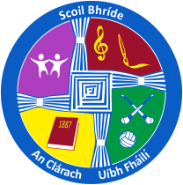
Scoil Bhríde
Clara Co Offaly
Roll No: 13118U

Child’s Name: D.O.B. Class:

Allergy

What we notice:

Instructions for administration of medicine:

Signed: _____________________________________ Date: __________
Parent

_____________________________________ Date: __________
Principal

Nora Kavanagh
Principal: Nora Kavanagh Phone: 057 93 31483 Email: sbclara@eircom.net
Deputy Principal: Sandra Grennan Website: www.sbclara.ie Facebook: Scoil Bhríde Girls NS
Roll No: 13118U
Nora Kavanagh - Principal

